Hello Kentucky DECA, as always the month of December has been a busy month for the state officer team. As you already know December 15th was the deadline for competition. We are so excited for the competition season to start.

The state officer team met on December 16th, we had a very successful meeting about our upcoming board meeting in January, state conference, and other opportunities for the officer team.

As many of you know, the western portion of our Commonwealth was hit very hard by a tornado. DECA members are family and many of our DECA family members were impacted by the recent storms. The state officer team wants each of you to know that if you were impacted by the storms earlier this month, that you and your family are in our thoughts and prayers this holiday season.

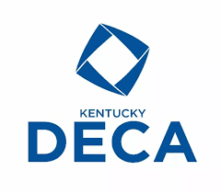
On behalf of Mrs. Lisa Oakes, and the entire state officer team we wish you a very Merry Christmas and a Happy New Year. See you in 2022, get ready for competition Kentucky DECA.

